Project Design Phase-II
Technology Stack (Architecture & Stack)

Date | 27 Feb 2026
Team ID | LTVIO2026TMIDS46648
Project Name | Electric Motor Temperature Prediction using AIML
Maximum Marks | 4 Marks

Technical Architecture:
The Deliverable shall include the architectural diagram as below and the information as per the table1 & table 2
Example: Electric Motor Temperatute Prediction
Reference: https://developer.ibm.com/patterns/ai-powered-backend-system-for-order-processing-during-pandemics/
Guidelines:
Include all the processes (As an application logic / Technology Block)
Provide infrastructural demarcation (Local / Cloud)
Indicate external interfaces (third party API’s etc.)
Indicate Data Storage components / services
Indicate interface to machine learning models (if applicable)

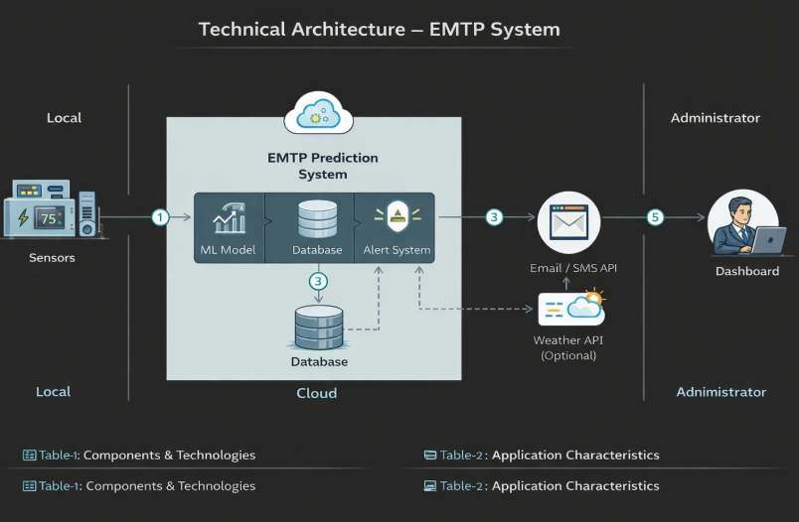

Table-1 : Components & Technologies:
S.No | Component | Description | Technology
1 | User Interface | Dashboard to monitor motor temperature & alerts | HTML, CSS, JavaScript / React.js
2 | Application Logic-1 | Data preprocessing & sensor data handling | Python (Flask)
3 | Application Logic-2 | ML model integration for prediction | Scikit-learn / TensorFlow
4 | Application Logic-3 | Alert generation logic | Python
5 | Database | Store historical motor data | MySQL / PostgreSQL
6 | Cloud Database | Cloud data storage (optional) | Firebase / AWS RDS
7 | File Storage | Store logs & datasets | Local File System / AWS S3
8 | External API-1 | Email notification service | SMTP / SendGrid API
9 | External API-2 | SMS alert service | Twilio API
10 | Machine Learning Model | Predict motor temperature & failures | Random Forest / XGBoost
11 | Infrastructure | Deployment environment | Local Server / AWS / Azure Cloud

Table-2: Application Characteristics:
S.No | Characteristics | Description | Technology
1 | Open-Source Frameworks | Web & ML frameworks used | Flask, Scikit-learn, React
2 | Security Implementations | Secure login & encrypted data | HTTPS, JWT, SHA-256
3 | Scalable Architecture | 3-tier architecture (UI, Logic, DB) | Cloud Deployment (AWS/Azure)
4 | Availability | System accessible 24/7 | Cloud Hosting + Load Balancer
5 | Performance | Fast prediction response (<3 sec) | Optimized ML model + Caching

References:
https://c4model.com/
https://developer.ibm.com/patterns/online-order-processing-system-during-pandemic/
https://www.ibm.com/cloud/architecture
https://aws.amazon.com/architecture
https://medium.com/the-internal-startup/how-to-draw-useful-technical-architecture-diagrams-2d20c9fda90d

